Sydney Bathroom Hire
Luxury Portable Shower Units

Requirements Checklist

Showers are 1.250 meters square and 2.350 meters high.
Delivery on to your property is by hand trolley via hard
level ground. Please ensure the shower will fit where
you want it to go including room to tilt shower into position.
The showers are 86 kilograms so they can be lifted by
two people. If the showers are to go up several stairs
two able bodied persons (minimum) must be available
on site for delivery and pick up. Extra charges will apply if
we cannot pick up due to insufficient labour as per conditions.
- The hot water system must be positioned on a hard level
surface. The hot water system must be situated so it is
unable to be tipped over and is away from foot traffic etc.

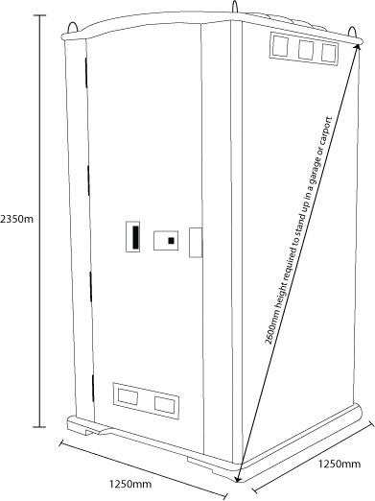

- The hot water system must be positioned on a hard level
surface. The hot water system must be situated so it is
unable to be tipped over and is away from foot traffic etc.

- 20 meters of water hose is supplied to connect the hot
water system to a garden tap. Please let us know if extra
hose are required.

- The hot water system requires a 10 AMP (General Power Outlet) power outlet in good condition. The hot water system must not share a power point with any other large appliances. Power boards and double adaptors can not be used. We supply a 30 meter leads, tagged and tested for your safety. (Power lead can be supplied with built in RCD (safety switch) if your power point is external (Weather protected)

- Waste water from the shower runs out the base of the shower. The waste water cannot run into storm water. If the water is to go in to the sewer line than the entry to the sewer line must below the ground level of the shower unit. Please check with your local council in regards to grey water disposal.

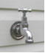
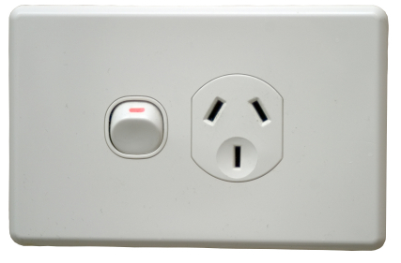

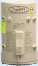
“For all your portable bathroom solutions”

